**Task 6**

**`**

**Q1) Fire alarm systems are one of the most critical components in any large-scale project. I would like you to use this information and provide me with further details about it.**

**1. number of features With python (pandas)**

**2. number of data With python (pandas)**

**3. drop column (UTC) With python (pandas)**

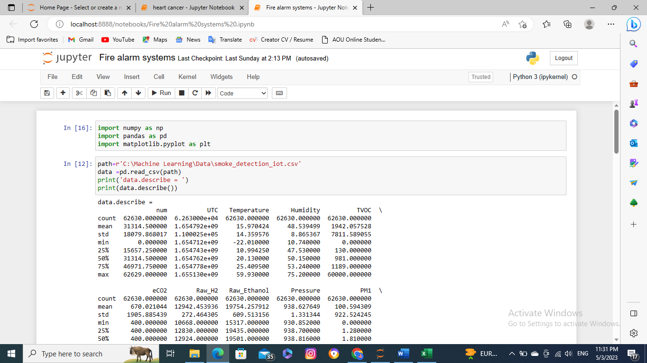

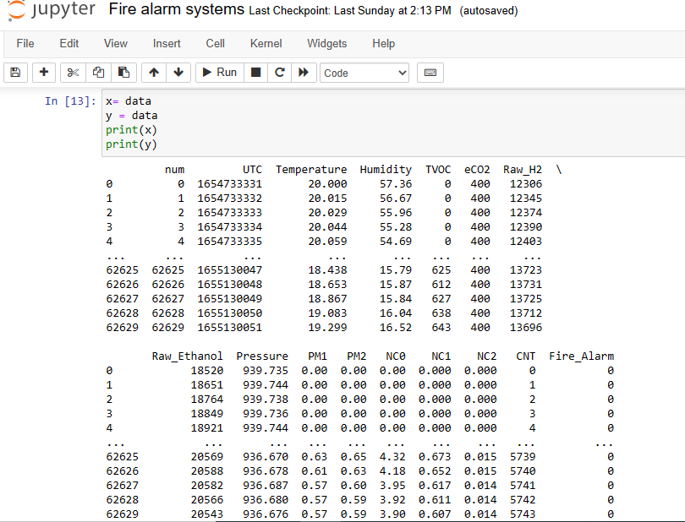

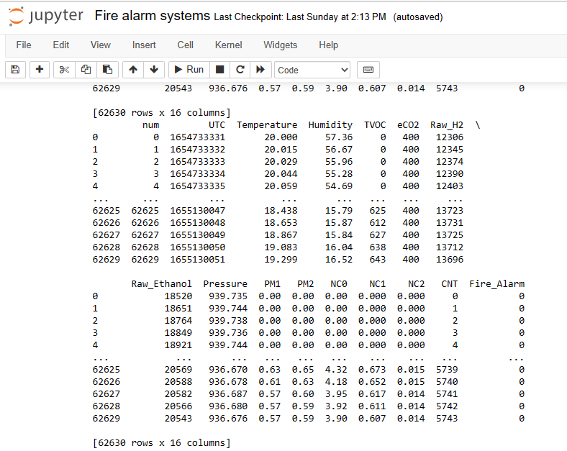

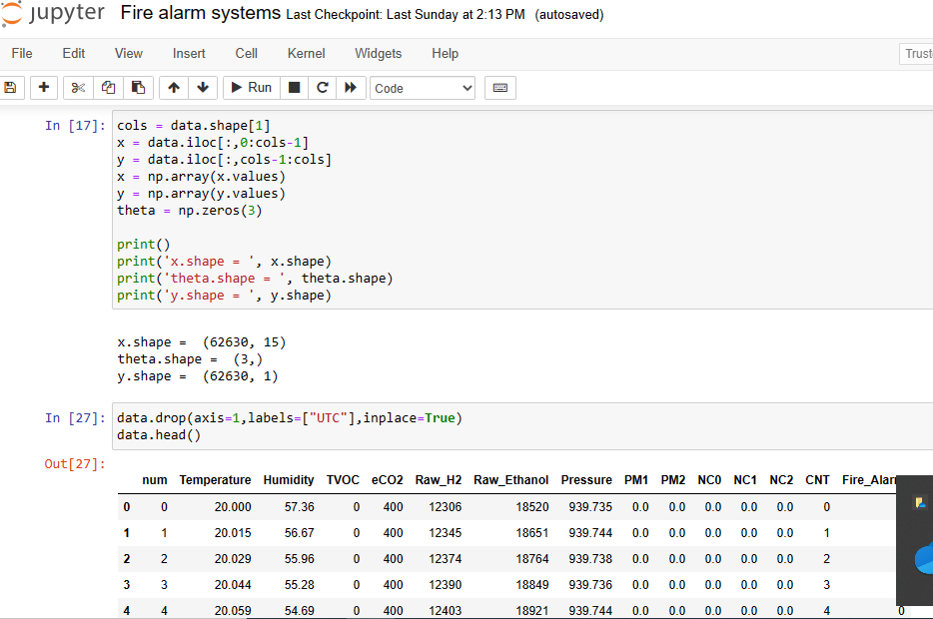

**Q2)**

**which algorithm to use (SVM or LR)**

SVM

**data link :**

[**https://github.com/Momen2410/Machine-Learning-Course/blob/main/Data/smoke_detection_iot.csv**](https://github.com/Momen2410/Machine-Learning-Course/blob/main/Data/smoke_detection_iot.csv)

**Q1 🡺 90 points**

**Q2 🡺 10 points**

**Good luck**